Dataset Comparison Report: Western vs Indian Gene Expression

1. Dataset Overview
Western Dataset: 6322 samples (5436 tumor, 886 normal)
Indian Dataset: 232 samples (116 tumor, 116 normal)
Common Genes: 566
Western-only Genes: 0, Indian-only Genes: 0

2. Basic Expression Statistics with Expression Level Comparison
Western Global Mean: 0.0423, Std: 1.049
Indian Global Mean: 0.0853, Std: 0.5996
Mean Expression Correlation: 0.5671
Std Expression Correlation: 0.3685
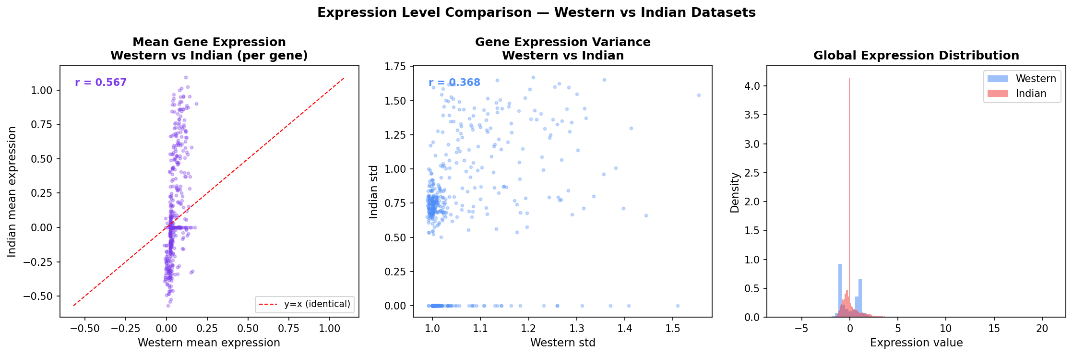

3. PCA Visualization
PC1 Variance: 69.16%, PC2 Variance: 11.68%
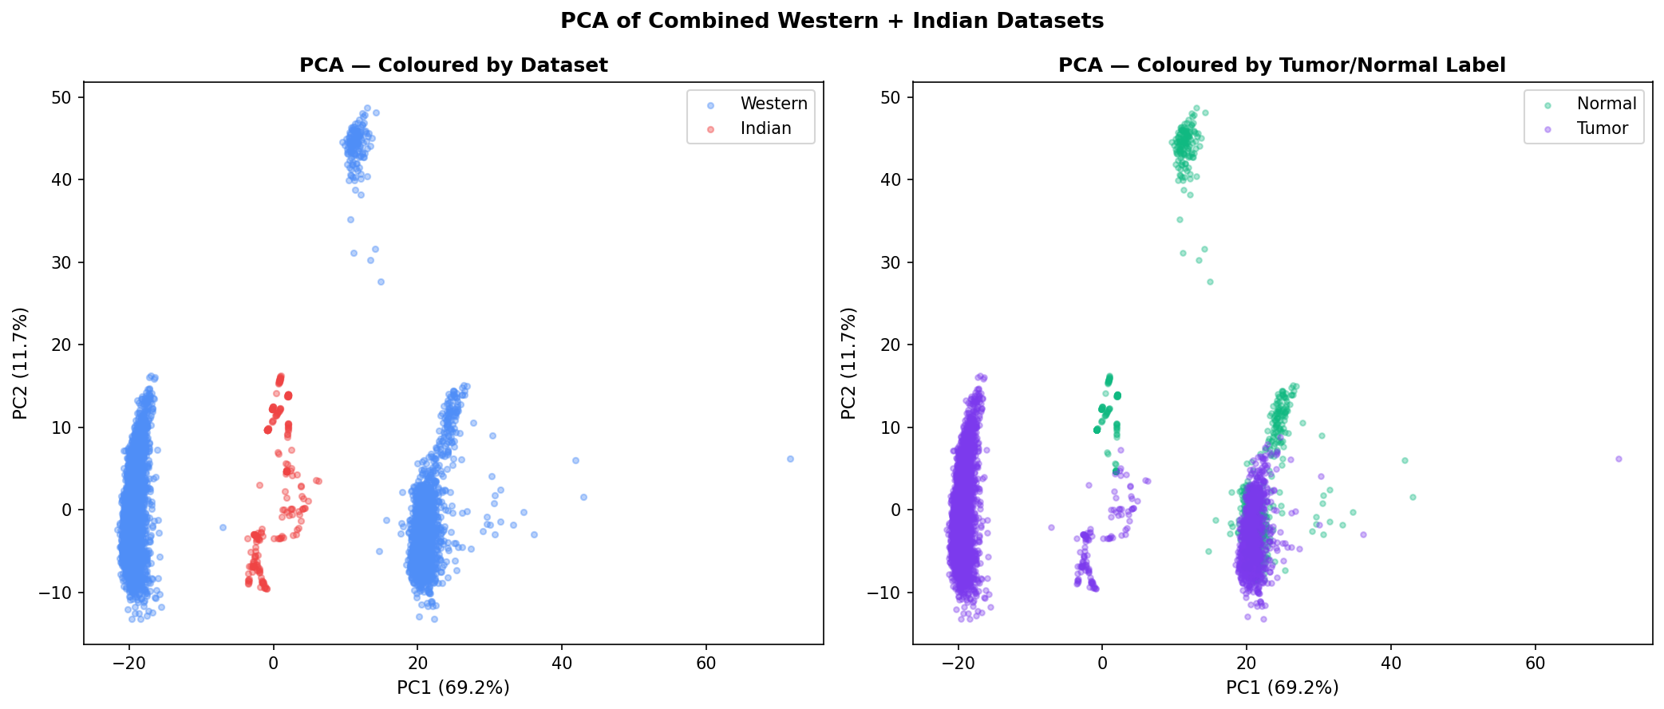

4. UMAP Visualization
UMAP visualization of the combined datasets.
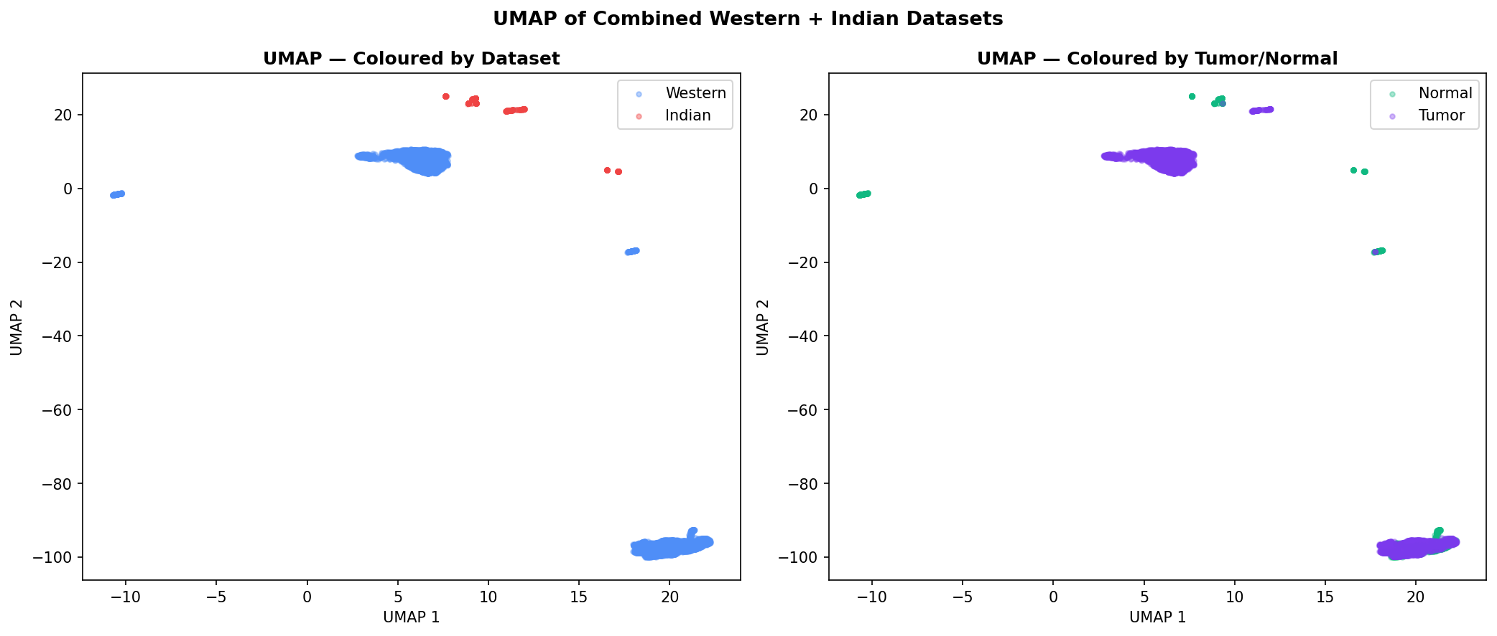

5. Mann-Whitney U Test
Significant Genes (Mann-Whitney): 158 (27.9%)
Median Log2 Fold Change: nan
Percent Upregulated in Indian: 34.3%, Downregulated: 37.6%
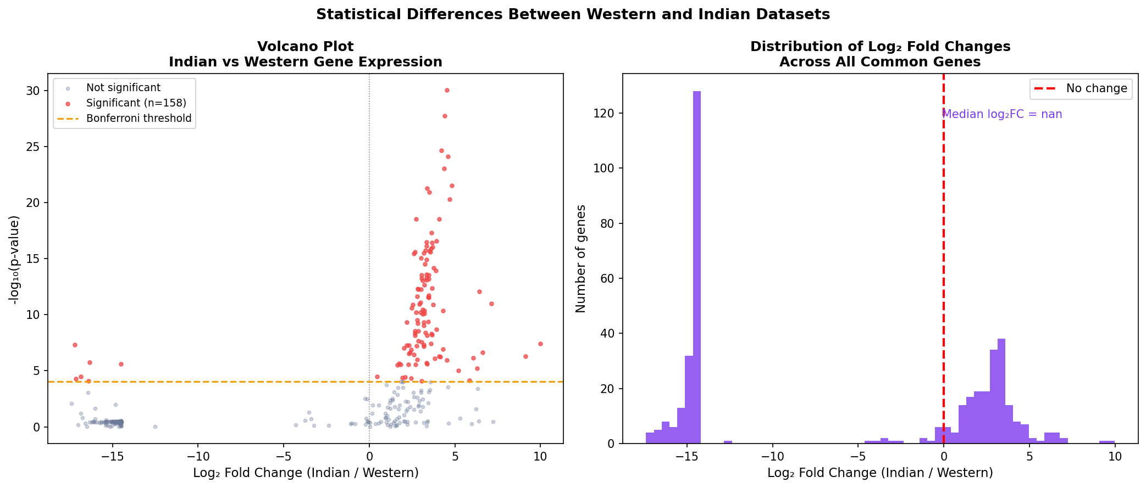

6. Top 30 Gene Significance (RF+SHAP) with Top 30 Gene Comparison and Mean Expression Heatmap
Overlap: 3 genes
Western-only: 27 genes
Indian-only: 27 genes
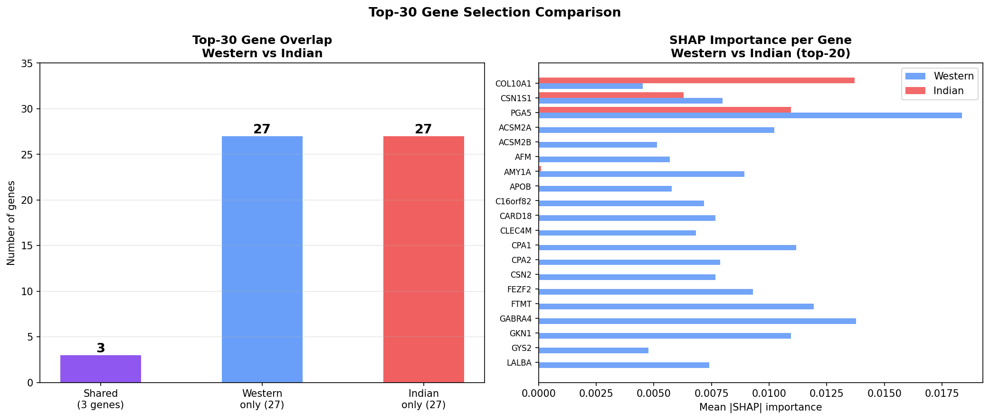
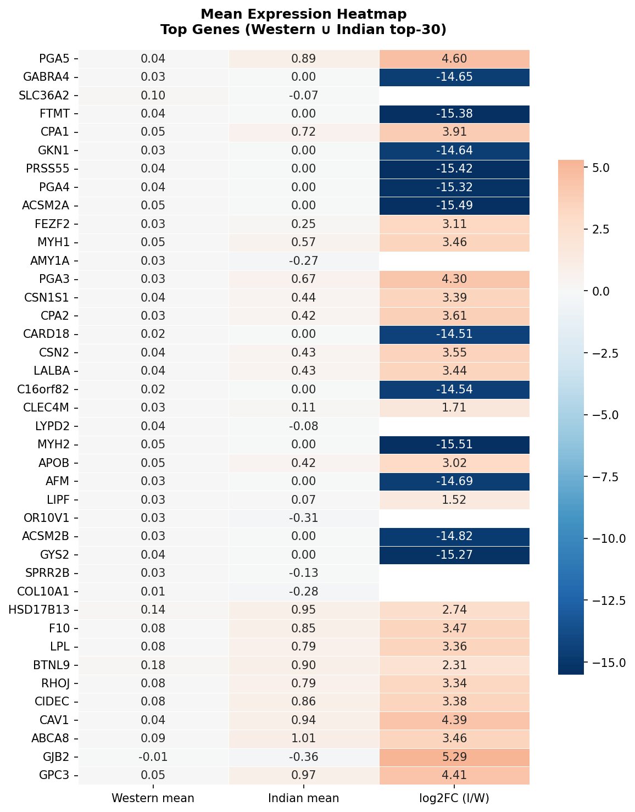

7. KL Divergence (Distribution Shift)
Mean KL Divergence: 11.2454
Top KL Gene: MBD3L5 (value: 23.8692)
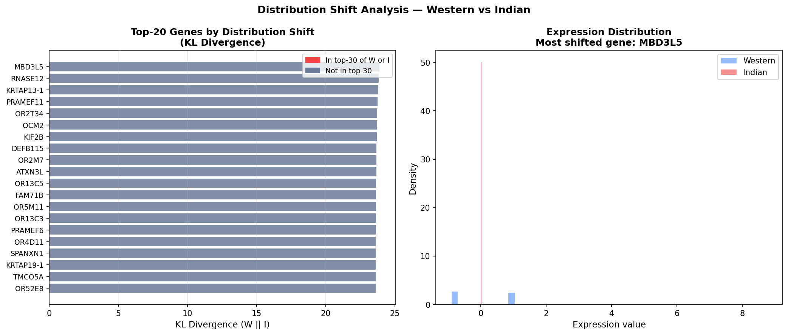

8. Correlation Structure
Mean Correlation Difference: nan
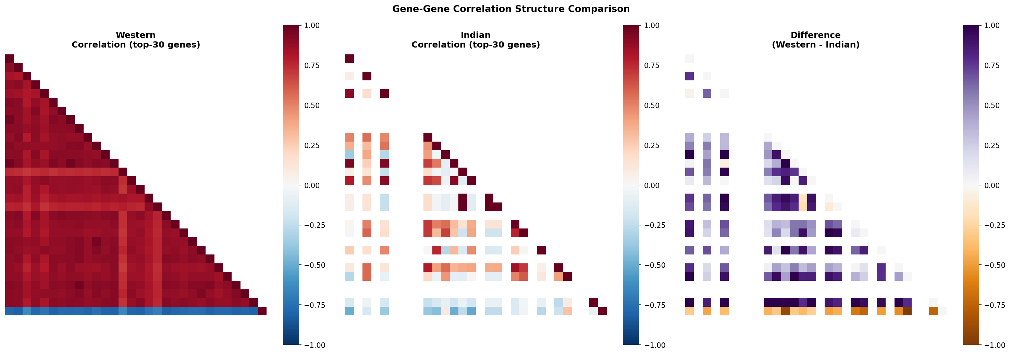

9. PCA Scree/Cumulative Variance
PCs for 80% Variance - Western: 2, Indian: 7
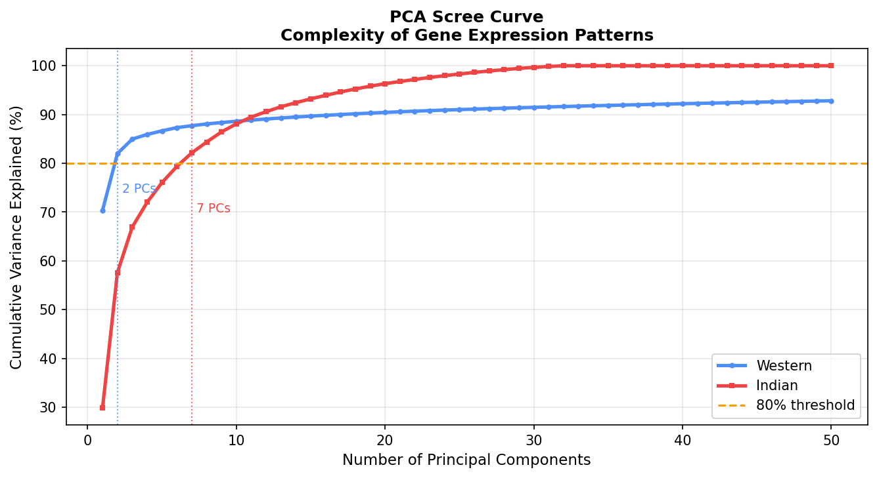

10. Summary Statistics and Gene Lists

Summary Statistics
Statistic | Value
western_samples | 6322
western_tumor | 5436
western_normal | 886
indian_samples | 232
indian_tumor | 116
indian_normal | 116
common_genes | 566
western_only_genes | 0
indian_only_genes | 0
western_global_mean | 0.0423
indian_global_mean | 0.0853
western_global_std | 1.049
indian_global_std | 0.5996
mean_expression_correlation | 0.5671
std_expression_correlation | 0.3685
pca_var_pc1 | 69.16
pca_var_pc2 | 11.68
sig_genes_mannwhitney | 158
sig_genes_ks | 560
bonferroni_alpha | 8.8339222614841e-05
pct_sig_mannwhitney | 27.9
median_log2fc | nan
pct_upregulated_indian | 34.3
pct_downregulated_indian | 37.6
top30_overlap | 3
top30_only_w | 27
top30_only_i | 27
mean_kl_divergence | 11.2454
median_kl_divergence | 6.1971
top_kl_gene | MBD3L5
top_kl_value | 23.8692
mean_corr_diff | nan
pcs_80pct_variance_western | 2
pcs_80pct_variance_indian | 7

Top 30 Western Genes
Gene Name
PGA5
GABRA4
SLC36A2
FTMT
CPA1
GKN1
PRSS55
PGA4
ACSM2A
FEZF2
MYH1
AMY1A
PGA3
CSN1S1
CPA2
CARD18
CSN2
LALBA
C16orf82
CLEC4M
LYPD2
MYH2
APOB
AFM
LIPF
OR10V1
ACSM2B
GYS2
SPRR2B
COL10A1

Top 30 Indian Genes
Gene Name
HSD17B13
F10
LPL
BTNL9
RHOJ
CIDEC
CAV1
ABCA8
GJB2
GPC3
COL10A1
ARHGAP20
ADH1B
EGR1
PGA5
CAPN11
LIMS2
SCARA5
C1QTNF9
LEPR
SRPX
CAV2
CA4
SPRY2
CACHD1
CD300LG
SHE
CSN1S1
LMOD1
GSN

Overlapping Genes
Gene Name
COL10A1
CSN1S1
PGA5

Top 50 KL Divergence Genes
Gene Name | KL Divergence
MBD3L5 | 23.86921822163068
RNASE12 | 23.820724928447508
KRTAP13-1 | 23.792681618071946
PRAMEF11 | 23.741785075028545
OR2T34 | 23.717757381822643
OCM2 | 23.70957931875233
KIF2B | 23.682707571844645
DEFB115 | 23.66894310913596
OR2M7 | 23.658827480326675
ATXN3L | 23.65440611522139
OR13C5 | 23.63976477930921
FAM71B | 23.638300053022316
OR5M11 | 23.6339717279634
OR13C3 | 23.63130491277225
PRAMEF6 | 23.619396347095005
OR4D11 | 23.614873144975697
SPANXN1 | 23.614268555396947
KRTAP19-1 | 23.61419459039353
TMCO5A | 23.61178693684275
OR52E8 | 23.60376205479765
OR13H1 | 23.603659477359365
MAGEB16 | 23.591722706662107
OR5T3 | 23.58304372006844
OR4C11 | 23.58018207266708
OPN1MW | 23.579553571411143
OR5T1 | 23.578598029606383
OR5M10 | 23.575730069593952
KRTAP13-2 | 23.558549843548608
ADAD1 | 23.546208336631
OR2T4 | 23.539090702858168
OR4P4 | 23.52669394609804
OR5K3 | 23.526625954489774
OR5H15 | 23.52338498258039
OR10K2 | 23.516365171031243
KRTAP12-2 | 23.51570003408716
OR51F2 | 23.51067727911609
OR6K2 | 23.510224321748705
OR6X1 | 23.5088734332382
C5orf52 | 23.49246431435455
OR5J2 | 23.49082858286411
IFNA7 | 23.49001213560205
DEFB136 | 23.485575872377638
OR4K14 | 23.48409137878681
OTOL1 | 23.481708170606638
OR5AR1 | 23.476967621305665
LCE3E | 23.472030129067395
KDM5D | 23.47144745447045
OR13F1 | 23.471014058541343
OR8B2 | 23.46876424743722
PRAMEF20 | 23.467582522275105

